Тестування інтерфейсу користувача (GUI). Тестування веб застосунків
Завдання 1. Протестуй UI/UX сайту Оксфорд Медикал. В Google docs створи 5 багів з дотриманням усіх вимог до оформлення багу.

Bug 1
Title: Job links on the “Вакансії” page redirect to incorrect vacancies
Environment:
macOS, Google Chrome
Preconditions:
The Oxford Medical “Вакансії” page is open in Ukrainian.
Вакансії приватної медичної клініки Оксфорд Медікал Київ
Steps to Reproduce:
- In the “Відкриті вакансії” section click the external job link for the “Адміністратор медичної клініки на Позняках” vacancy.
- Return to the “Відкриті вакансії” section and click the external job link for the “Гастроентеролог в різних районах Києва та в Ірпені” vacancy.
- Return to the “Відкриті вакансії” section and click the external job link for the “Лікар УЗД в різних районах Києва та в Ірпені” vacancy.
Actual Result:
The job links redirect to unrelated vacancies. The “Адміністратор медичної клініки на Позняках” link opens the “Бухгалтер з первинної документації” vacancy, the “Гастроентеролог в різних районах Києва та в Ірпені” link opens the “Ендокринолог” vacancy, and the “Лікар УЗД в різних районах Києва та в Ірпені” link opens the “Лікар терапевт” vacancy.
Attachment:
Bug 1.Screenshots
Expected Result:
Each job link should redirect to the corresponding vacancy.
Severity: Minor
Priority: Medium

Bug 2
Title: External job link is missing for the “Травматолог на Виноградарі” vacancy
Environment:
macOS, Google Chrome
Preconditions:
The Oxford Medical “Вакансії” page is open in Ukrainian.
Вакансії приватної медичної клініки Оксфорд Медікал Київ
Step to Reproduce:
In the “Відкриті вакансії” section check the external job link under the “Травматолог на Виноградарі” vacancy.
Actual Result:
There is no external job link under the “Травматолог на Виноградарі” vacancy, while other vacancies have WORK.ua or Robota.ua links.
Attachment:
Bug 2.Screenshot
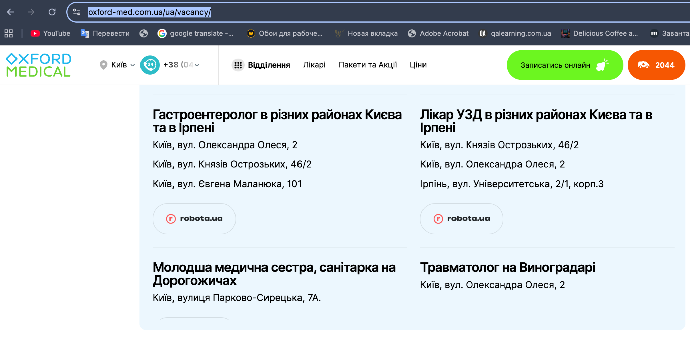
Expected Result:
An external job link should be displayed under the “Травматолог на Виноградарі” vacancy, as it is for the other vacancies.
Severity: Minor
Priority: Medium

Bug 3
Title: Ukrainian service category names are displayed on the English “Prices” page
Environment:
macOS, Google Chrome
Preconditions:
The Oxford Medical “Prices” page is open in English.
Price - Oxford Medical private clinic in Kiev
Step to Reproduce:
Check the service category names on the “Prices” page.
Actual Result:
The “Естетична медицина”, and “Пакетні та Акційні пропозиції” category names are displayed in Ukrainian.
Attachment:
Bug 3.Screenshot
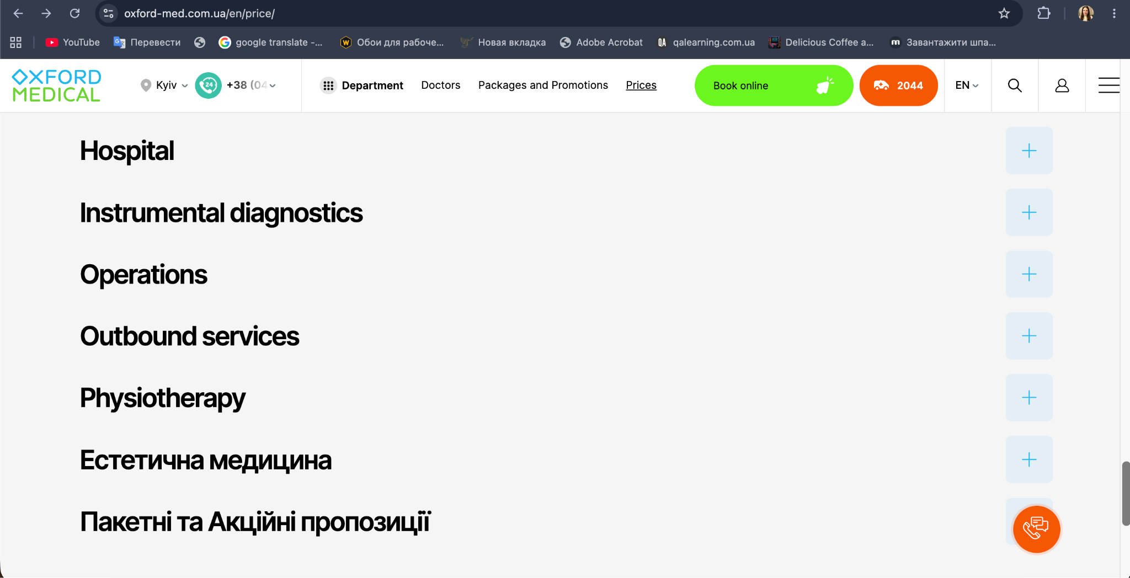
Expected Result:
All service category names should be displayed in English.
Severity: Minor
Priority: Low

Bug 4
Title: The “Арсенал Ассистанс” logo appears clickable but does not perform any action when clicked
Environment:
macOS, Google Chrome
Preconditions:
The Oxford Medical “About Us” page is open in Ukrainian.
Oxford Medical | About Us
Steps to Reproduce:
- Scroll down to the “Наші партнери” section.
- Find the “Арсенал Ассистанс” logo.
- Hover the cursor over the “Арсенал Ассистанс” logo.
- Click the “Арсенал Ассистанс” logo.
Actual Result:
The cursor changes to a pointer and a URL is displayed in the browser, but clicking the “Арсенал Ассистанс” logo does not perform any action.
Attachment:
Bug 4.Screenshot
Expected Result:
The “Арсенал Ассистанс” logo should redirect to the corresponding page when clicked or should not appear clickable if no action is available.
Severity: Trivial
Priority: The lowest

Bug 5
Title: Misspelled word “Виїздні” is displayed instead of “Виїзні”
Environment:
macOS, Google Chrome
Preconditions:
The Oxford Medical Home page is open in Ukrainian.
Оксфорд Медікал
Steps to Reproduce:
- Click the “Відділення” button in the header.
- Find the “Виїздні послуги” category.
- Click the “Виїздні послуги” category.
Actual Result:
The misspelled word “Виїздні” is displayed in the category name and after opening the category.
Attachment:
Bug 5.Screenshots
Expected Result:
The grammatically correct word “Виїзні” should be displayed instead of “Виїздні”.
Severity: Trivial
Priority: Medium

UX Observation
Website pages contain too many interface elements and repeated information, which makes the website visually overloaded. A simpler structure with less duplicated content could make navigation easier and improve the overall user experience.
Завдання 2-3. Проведи кросбраузерне тестування знайдених раніше багів у трьох різних браузерах. Додай результати до зафіксованих раніше багів.

Bug 1
Title: Job links on the “Вакансії” page redirect to incorrect vacancies
Cross-browser Testing:
Mozilla Firefox: The bug is reproduced. The external job links redirect to vacancies that do not correspond to the vacancies displayed on the Oxford Medical website.
Safari: The bug is reproduced. The external job links also redirect to vacancies that do not correspond to the vacancies displayed on the Oxford Medical website.

Bug 2
Title: External job link is missing for the “Травматолог на Виноградарі” vacancy
Cross-browser Testing:
Mozilla Firefox: The bug is reproduced. The “Травматолог на Виноградарі” vacancy is displayed without an external job link, while other vacancies have links to external job websites.
Safari: The bug is reproduced. The “Травматолог на Виноградарі” vacancy is also displayed without an external job link, while other vacancies have links to external job websites.

Bug 3
Title: Ukrainian service category names are displayed on the English “Prices” page
Cross-browser Testing:
Mozilla Firefox: The bug is reproduced. The “Естетична медицина”, and “Пакетні та Акційні пропозиції” category names are displayed in Ukrainian on the English version of the “Prices” page.
Safari: The bug is reproduced. The same category names are displayed in Ukrainian on the English version of the “Prices” page.

Bug 4
Title: The “Арсенал Ассистанс” logo appears clickable but does not perform any action when clicked
Cross-browser Testing:
Mozilla Firefox: The bug is reproduced. The behavior is the same as in Google Chrome: the cursor changes to a pointer and a URL is displayed when hovering over the “Арсенал Ассистанс” logo, but clicking the logo does not perform any action.
Safari: The bug is reproduced with a slight difference. The URL is not displayed when hovering over the “Арсенал Ассистанс” logo, but the cursor changes to a pointer, indicating that the logo is clickable. Clicking the logo does not perform any action.

Attachment:
Tasks 2-3
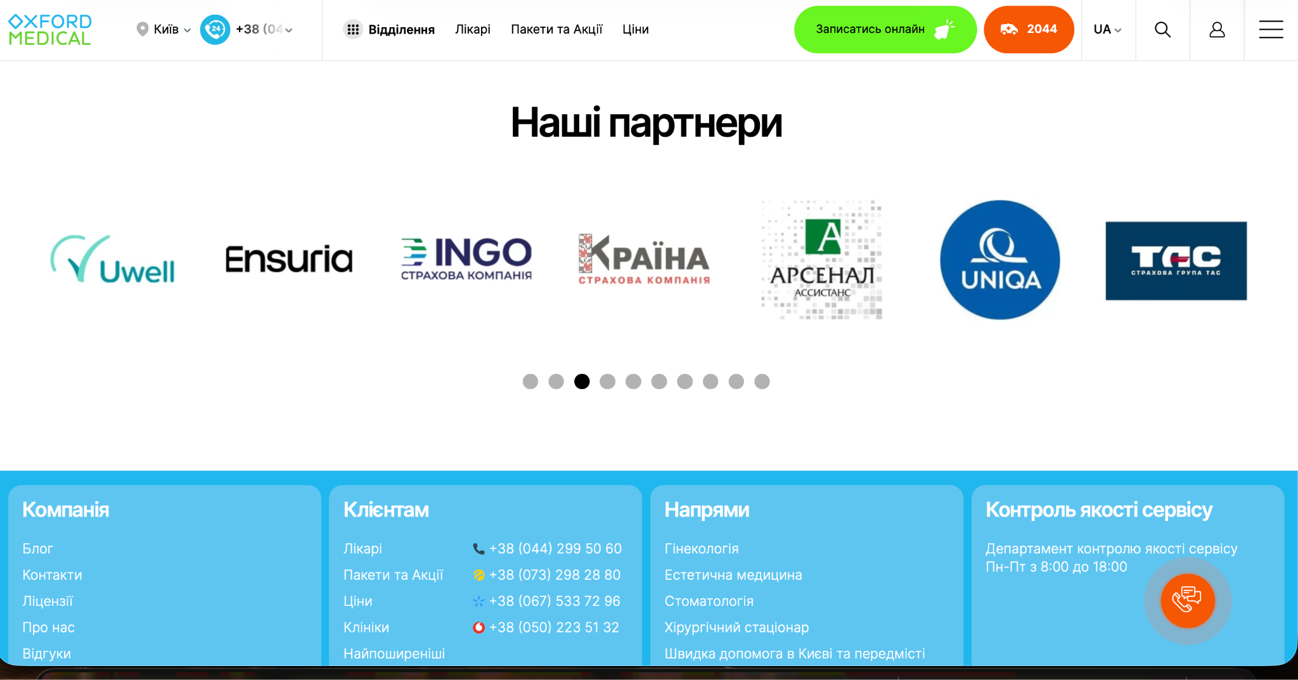

Bug 5
Title: Misspelled word “Виїздні” is displayed instead of “Виїзні”
Cross-browser Testing:
Mozilla Firefox: The bug is reproduced. The misspelled word “Виїздні” is displayed instead of “Виїзні” in the category name and after opening the category.
Safari: The bug is reproduced. The misspelled word “Виїздні” is displayed instead of “Виїзні” in the category name and after opening the category.

